Star-Cuploid

Definition
# Source: AI Source: Provided by: [Data Path: Persons Table -> ID Column: 1, Name_En Column: Motasem Essam] -> From: [ChatGPT] on [7/25/2026]
A Star-Cuploid is a non-convex, non-orientable polyhedron related to a star cupola. It is formed using a star-shaped polygonal base and an arrangement of triangular and square faces, with the degenerate lower polygonal base removed.
Unlike an ordinary cupola, which has two parallel polygonal bases, a star-cuploid has only one polygonal base. Its lateral faces connect around the structure in a crossed arrangement.
A star-cuploid is constructed using a star polygon represented by the Schläfli symbol:
$$\boxed{\{n/d\}}$$
where:
- $n$ = Number of vertices of the star polygon.
- $d$ = Step size, indicating how vertices are connected.
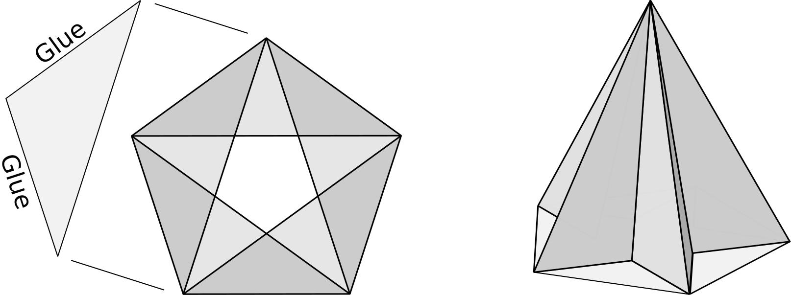

Simple Definition
# Source: AI Source: Provided by: [Data Path: Persons Table -> ID Column: 1, Name_En Column: Motasem Essam] -> From: [ChatGPT] on [7/25/2026]
A Star-Cuploid is a special type of polyhedron with:
- One star-shaped polygonal base.
- An arrangement of triangular and square faces.
- No separate lower polygonal base.
- Crossed or twisted connections between its faces.
- A non-orientable surface structure.
It is related to star cupolas but differs because its lower polygonal base is degenerate and is removed.

Geometric Structure
# Source: AI Source: Provided by: [Data Path: Persons Table -> ID Column: 1, Name_En Column: Motasem Essam] -> From: [ChatGPT] on [7/25/2026]
The Star-Cuploid consists of the following structural elements:
- Star-Shaped Base: A polygon whose edges cross one another, forming a star pattern.
- Triangular Faces: Triangular faces arranged around the star-shaped base.
- Square Faces: Square faces connecting portions of the star-shaped base to the surrounding structure.
- Crossed Connections: Connections that create the characteristic twisted arrangement.
- Degenerate Lower Boundary: The lower polygonal base is removed because it collapses into a degenerate polygon.
The structure is different from an ordinary cupola because the triangles and squares connect directly along the lower boundary instead of surrounding a separate lower polygonal base.
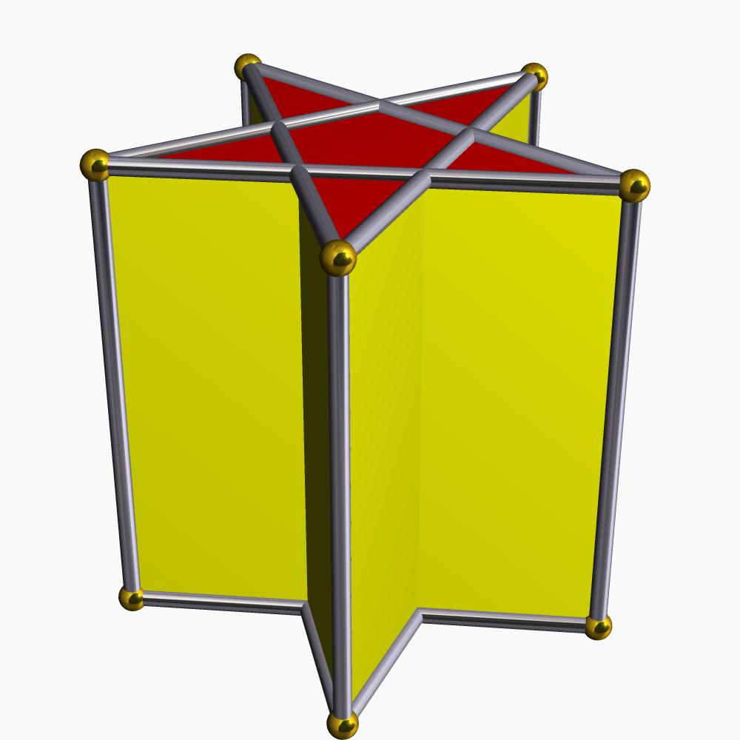

Face Structure
# Source: AI Source: Provided by: [Data Path: Persons Table -> ID Column: 1, Name_En Column: Motasem Essam] -> From: [ChatGPT] on [7/25/2026]
A Star-Cuploid contains different types of polygonal faces:

Star-Shaped Base
# Source: AI Source: Provided by: [Data Path: Persons Table -> ID Column: 1, Name_En Column: Motasem Essam] -> From: [ChatGPT] on [7/25/2026]
- The base is a star polygon.
- Its edges cross in a regular pattern.
- It is identified using the notation $\{n/d\}$.

Triangular Faces
# Source: AI Source: Provided by: [Data Path: Persons Table -> ID Column: 1, Name_En Column: Motasem Essam] -> From: [ChatGPT] on [7/25/2026]
- Triangular faces connect the star-shaped base to the surrounding structure.
- They fill gaps between the square faces.

Square Faces
# Source: AI Source: Provided by: [Data Path: Persons Table -> ID Column: 1, Name_En Column: Motasem Essam] -> From: [ChatGPT] on [7/25/2026]
- Square faces form the connecting portions of the polyhedron.
- They participate in the crossed arrangement characteristic of the cuploid.
Important: The exact number and arrangement of faces depend on the selected star polygon and its step size $d$. The different star-cuploids do not all have the same face arrangement.
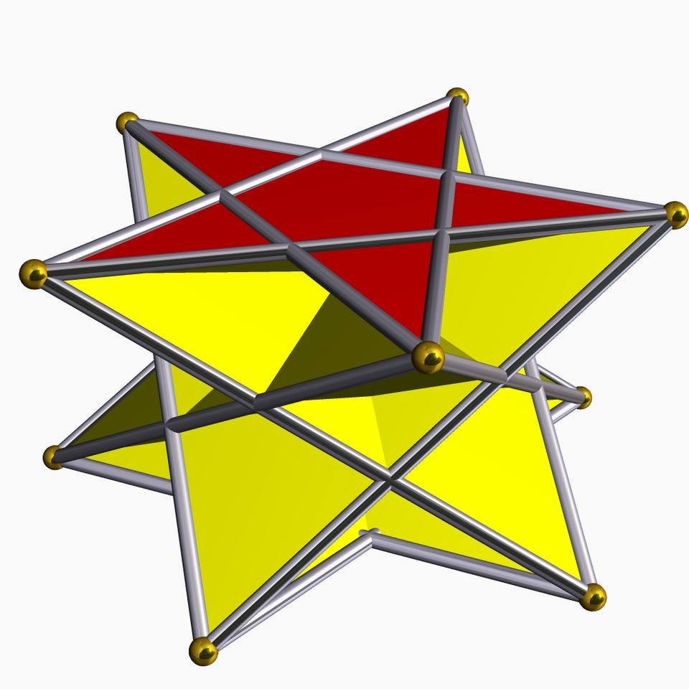

Edge Structure
# Source: AI Source: Provided by: [Data Path: Persons Table -> ID Column: 1, Name_En Column: Motasem Essam] -> From: [ChatGPT] on [7/25/2026]
The edges of a Star-Cuploid form the boundaries of its star-shaped base and lateral faces.
They include:
- Edges forming the star polygon.
- Edges connecting the triangular faces.
- Edges connecting the square faces.
- Shared edges between adjacent triangular and square faces.
The arrangement of the edges depends on the values of $n$ and $d$.
Because the structure can contain intersecting portions, it is important to distinguish actual polyhedral edges from apparent crossing lines in a drawing.

Vertex Structure
# Source: AI Source: Provided by: [Data Path: Persons Table -> ID Column: 1, Name_En Column: Motasem Essam] -> From: [ChatGPT] on [7/25/2026]
The vertices of a Star-Cuploid are arranged around the star-shaped base and its connecting faces.
They include:
- Vertices of the star polygon.
- Vertices shared by triangular and square faces.
- Vertices located at intersections in the geometric projection.
The number of vertices and the number of faces meeting at each vertex depend on the specific star-cuploid.
Important: A crossing in a two-dimensional projection does not automatically represent an additional three-dimensional vertex.
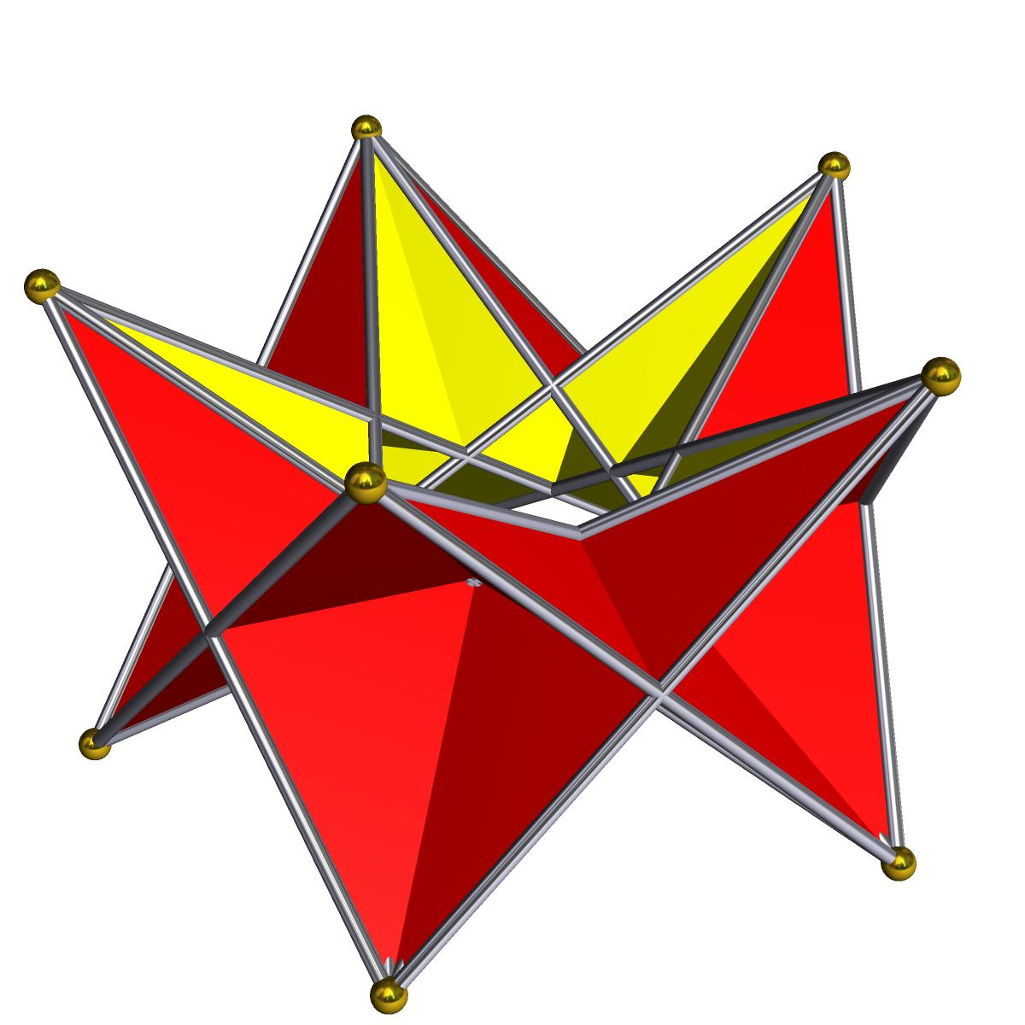

Mathematical Properties
# Source: AI Source: Provided by: [Data Path: Persons Table -> ID Column: 1, Name_En Column: Motasem Essam] -> From: [ChatGPT] on [7/25/2026]
The mathematical structure of a Star-Cuploid is described using the star-polygon notation:
$$\boxed{\{n/d\}}$$
Where:
- $n$ represents the number of vertices.
- $d$ represents the step size.
For example:
$$\{5/2\}$$
represents a pentagram, a five-pointed star polygon.
The notation determines the arrangement of the base, which influences the geometry of the entire cuploid.
Unlike ordinary convex cupolas, there is no single universal set of face, edge, and vertex formulas that can be applied to every star-cuploid without specifying its particular construction and how intersections are treated.

Face Incidence
# Source: AI Source: Provided by: [Data Path: Persons Table -> ID Column: 1, Name_En Column: Motasem Essam] -> From: [ChatGPT] on [7/25/2026]
Face incidence describes how the faces meet at the vertices and edges.
In a Star-Cuploid:
- Triangular faces meet square faces along shared edges.
- Several faces can meet around the star-shaped base vertices.
- The lateral faces form a crossed arrangement.
- The lower polygonal base is absent.
The exact vertex configuration depends on the selected star polygon.
A particularly important property is that star-cuploids are non-orientable. This means that their surface structure does not allow a consistent distinction between two sides throughout the entire surface.

Surface Area and Volume

Surface Area
# Source: AI Source: Provided by: [Data Path: Persons Table -> ID Column: 1, Name_En Column: Motasem Essam] -> From: [ChatGPT] on [7/25/2026]
The surface area is calculated by adding the areas of the polygonal faces:
$$S=A_{\text{base}}+\sum{A_{\text{triangles}}}+\sum{A_{\text{squares}}}$$
Where:
- $A_{\text{base}}$ = Area assigned to the star-shaped base.
- $A_{\text{triangles}}$ = Areas of the triangular faces.
- $A_{\text{squares}}$ = Areas of the square faces.
For self-intersecting star polygons, the base area depends on the chosen convention, such as signed area or the area of the enclosed star regions.

Volume
# Source: AI Source: Provided by: [Data Path: Persons Table -> ID Column: 1, Name_En Column: Motasem Essam] -> From: [ChatGPT] on [7/25/2026]
The volume of a Star-Cuploid is not calculated in the same straightforward way as an ordinary convex cupola.
Because the structure is non-orientable and may contain intersecting portions, a conventional enclosed volume may not be uniquely defined without specifying a particular geometric realization and a method for interpreting its interior.

Symmetry
# Source: AI Source: Provided by: [Data Path: Persons Table -> ID Column: 1, Name_En Column: Motasem Essam] -> From: [ChatGPT] on [7/25/2026]
Star-cuploids can have rotational and reflection symmetries determined by their star-polygon bases.
Their symmetry depends on the values of $n$ and $d$.
- Rotational Symmetry: The arrangement of the star polygon produces rotational symmetry around its central axis.
- Reflection Symmetry: Some star-cuploids have reflection symmetries depending on their construction.
- Non-Orientability: Their surface structure is non-orientable.
The exact symmetry group varies between different members of the family.
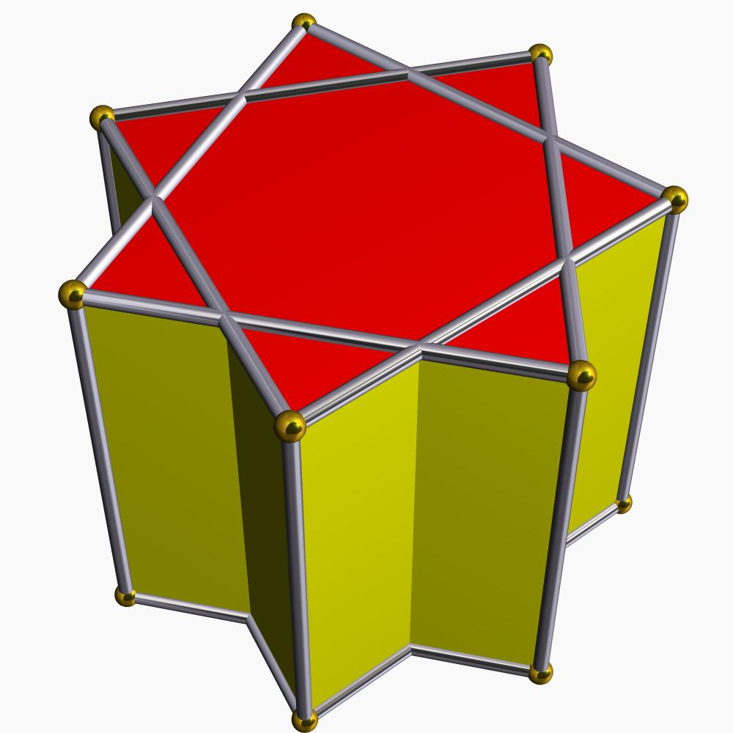

Types of Star-Cuploids
# Source: AI Source: Provided by: [Data Path: Persons Table -> ID Column: 1, Name_En Column: Motasem Essam] -> From: [ChatGPT] on [7/25/2026]
Star-cuploids include several forms based on their star-polygon bases.

Crossed Triangular Cuploid
# Source: AI Source: Provided by: [Data Path: Persons Table -> ID Column: 1, Name_En Column: Motasem Essam] -> From: [ChatGPT] on [7/25/2026]
A cuploid based on a crossed triangular star polygon, represented by $\{3/2\}$.
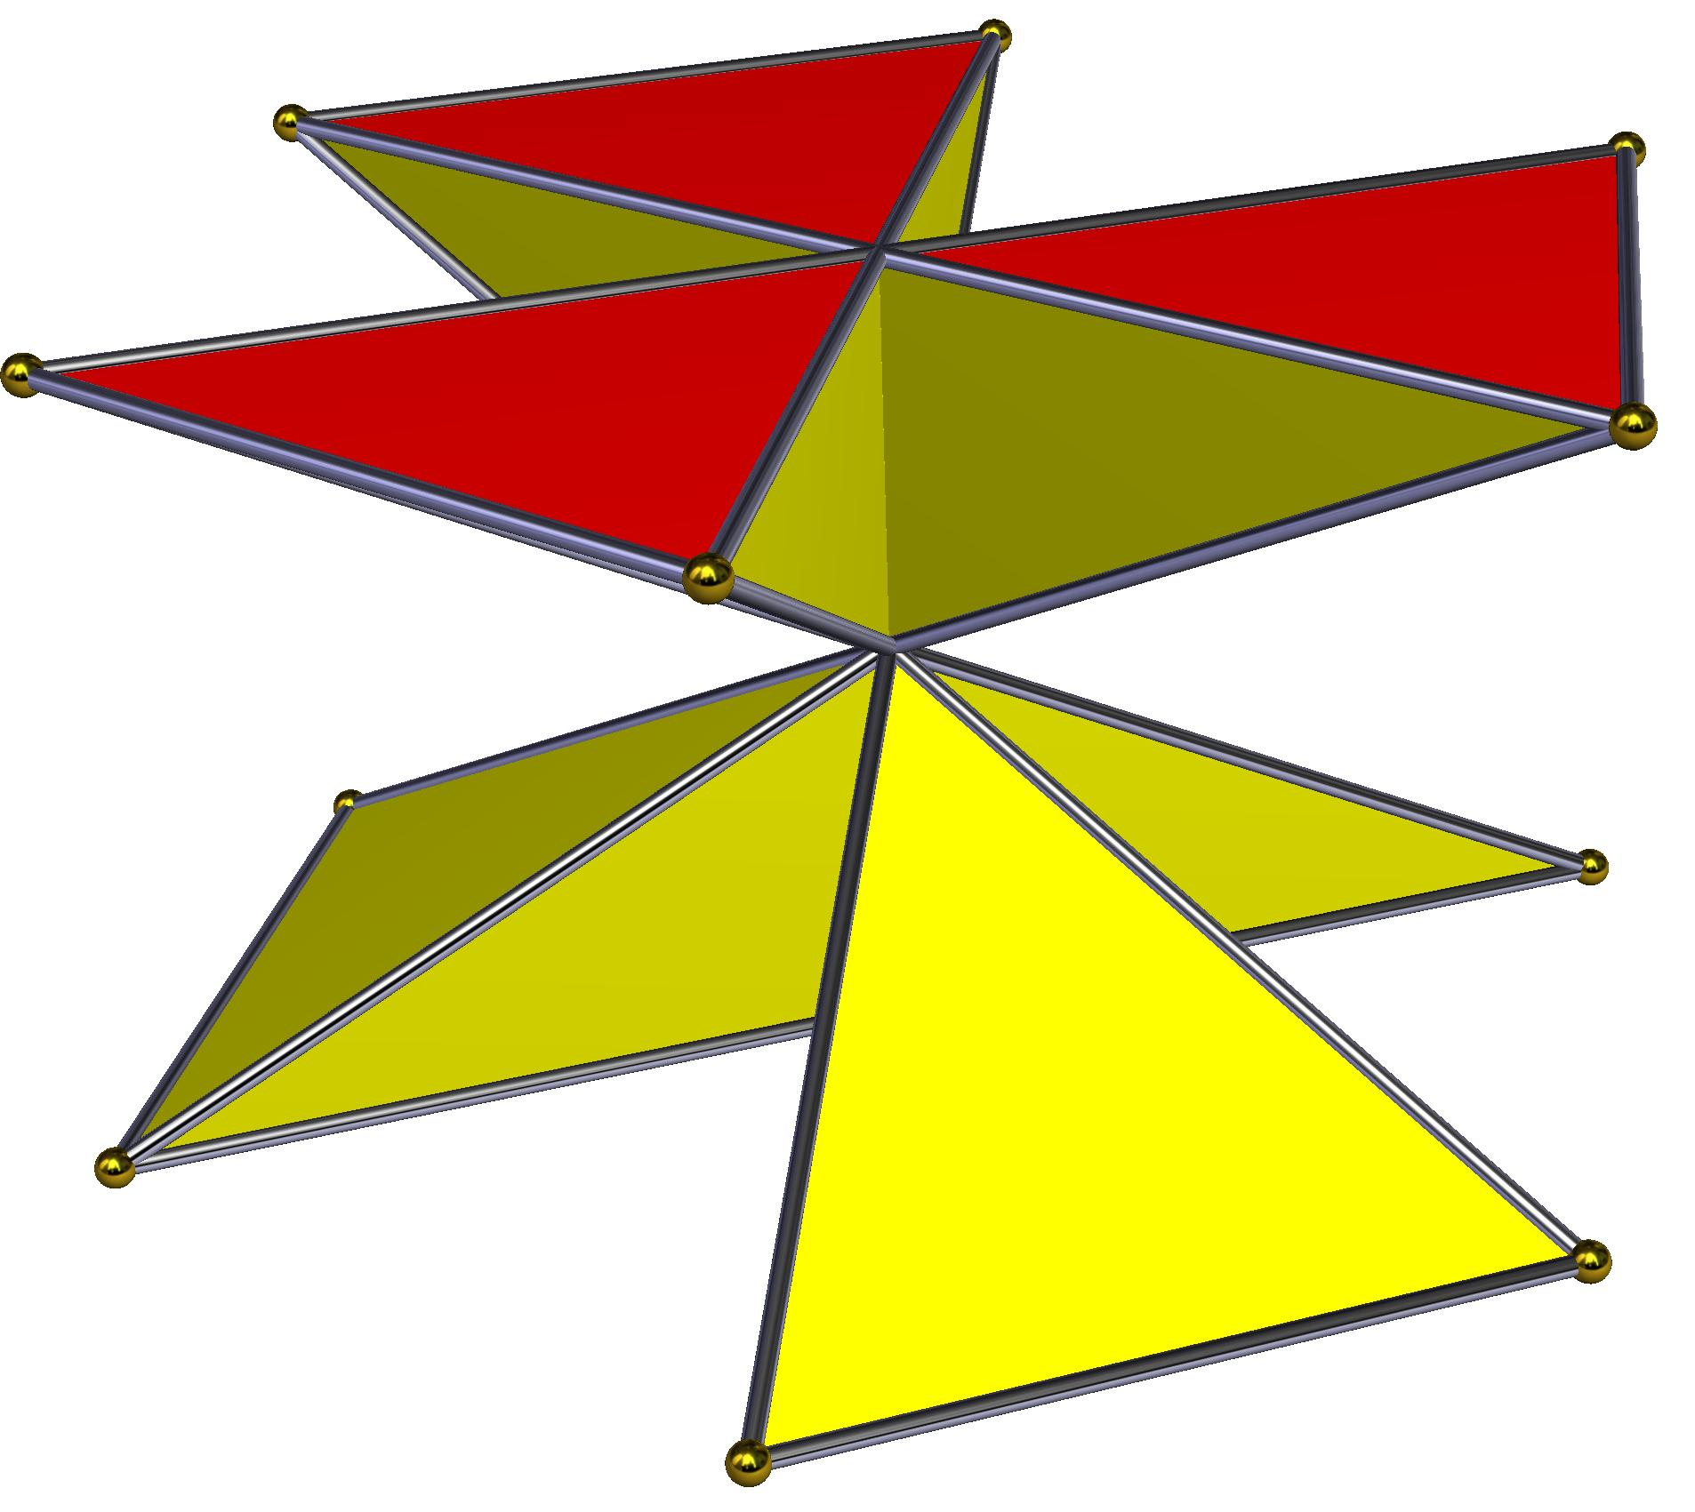

Pentagrammic Cuploid
# Source: AI Source: Provided by: [Data Path: Persons Table -> ID Column: 1, Name_En Column: Motasem Essam] -> From: [ChatGPT] on [7/25/2026]
A cuploid based on a pentagram, represented by $\{5/2\}$.

Heptagrammic Cuploid
# Source: AI Source: Provided by: [Data Path: Persons Table -> ID Column: 1, Name_En Column: Motasem Essam] -> From: [ChatGPT] on [7/25/2026]
A cuploid based on a seven-pointed star polygon, represented by $\{7/2\}$.
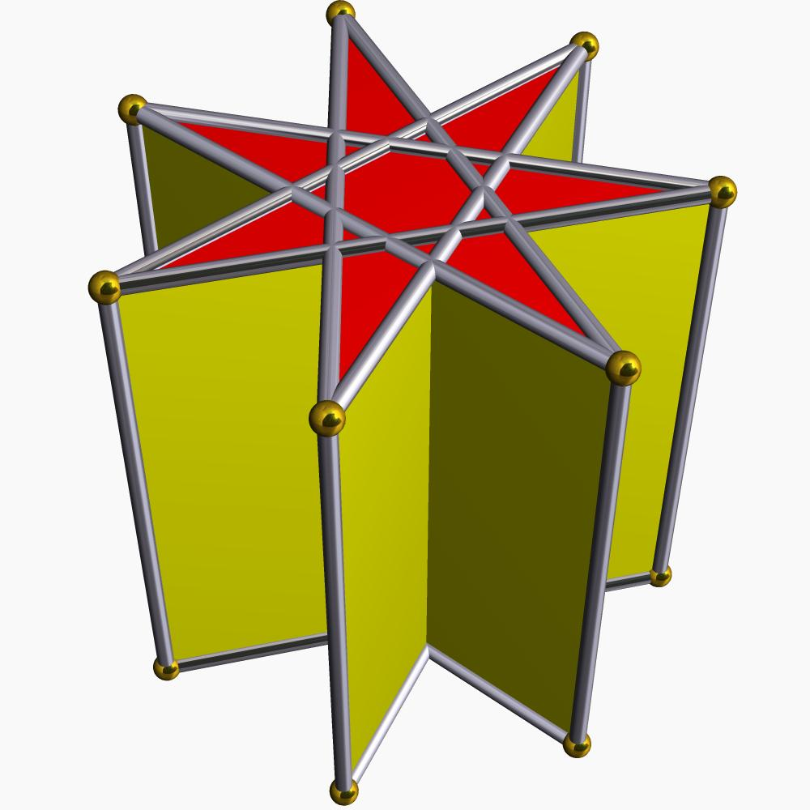

Crossed Pentagonal Cuploid
# Source: AI Source: Provided by: [Data Path: Persons Table -> ID Column: 1, Name_En Column: Motasem Essam] -> From: [ChatGPT] on [7/25/2026]
A crossed cuploid based on the star-polygon arrangement $\{5/4\}$.
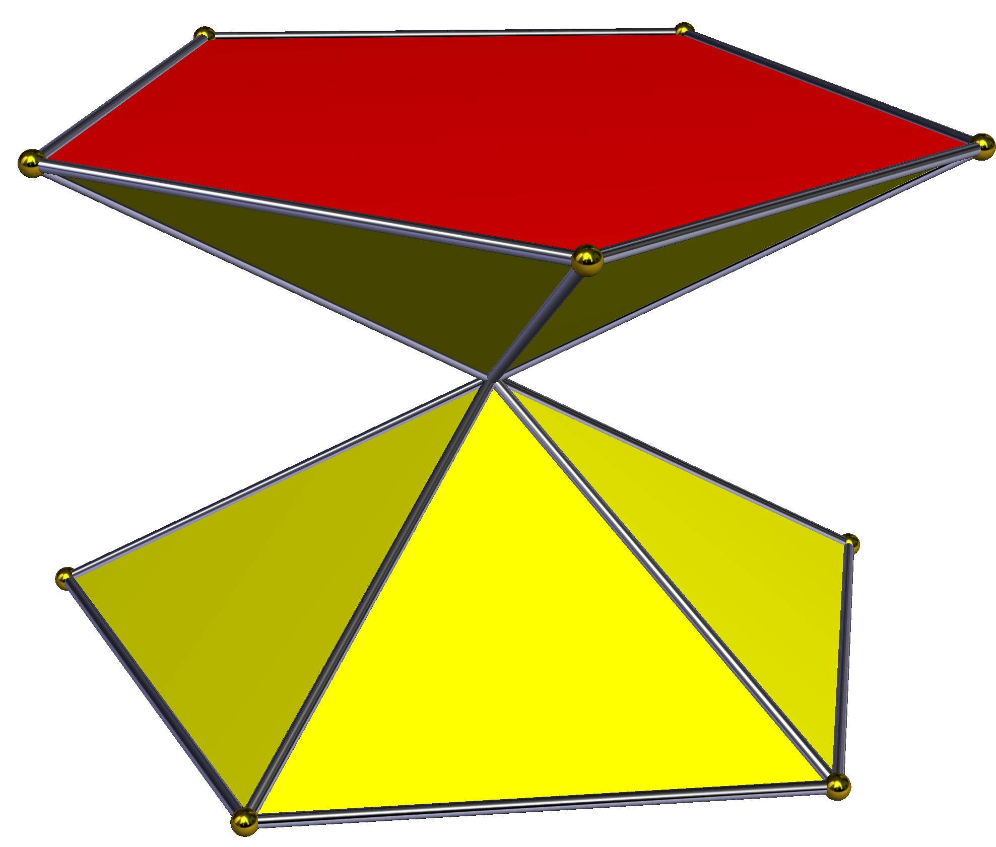

Crossed Heptagrammic Cuploid
# Source: AI Source: Provided by: [Data Path: Persons Table -> ID Column: 1, Name_En Column: Motasem Essam] -> From: [ChatGPT] on [7/25/2026]
A crossed cuploid based on the star-polygon arrangement $\{7/4\}$.
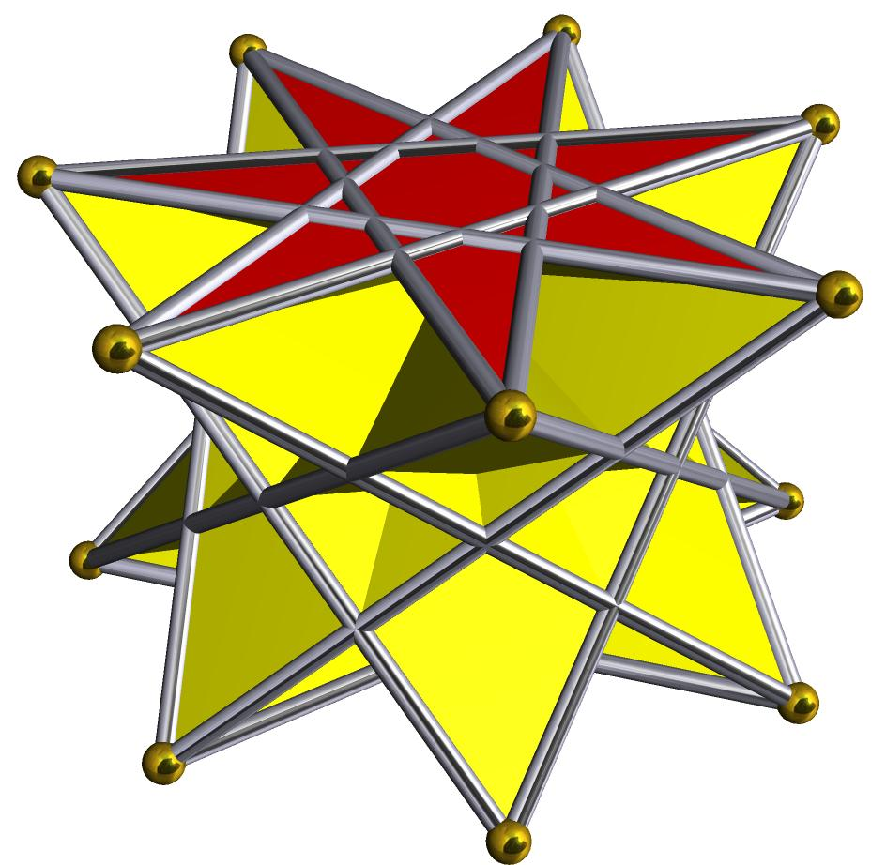

Worked Example
# Source: AI Source: Provided by: [Data Path: Persons Table -> ID Column: 1, Name_En Column: Motasem Essam] -> From: [ChatGPT] on [7/25/2026]
Problem: Identify the star polygon represented by the notation $\{5/2\}$ and explain its relationship to a Star-Cuploid.
Solution:
Given:
$$n=5, d=2$$
Step 1: Identify the polygon.
The notation $\{5/2\}$ represents a pentagram.
It has:
- 5 vertices.
- 5 star-forming edges.
- A step size of 2.
Step 2: Identify the corresponding cuploid.
A Star-Cuploid constructed using this star polygon is called a Pentagrammic Cuploid.
Step 3: Describe its structure.
It has a pentagrammic base and a surrounding arrangement of triangular and square faces.
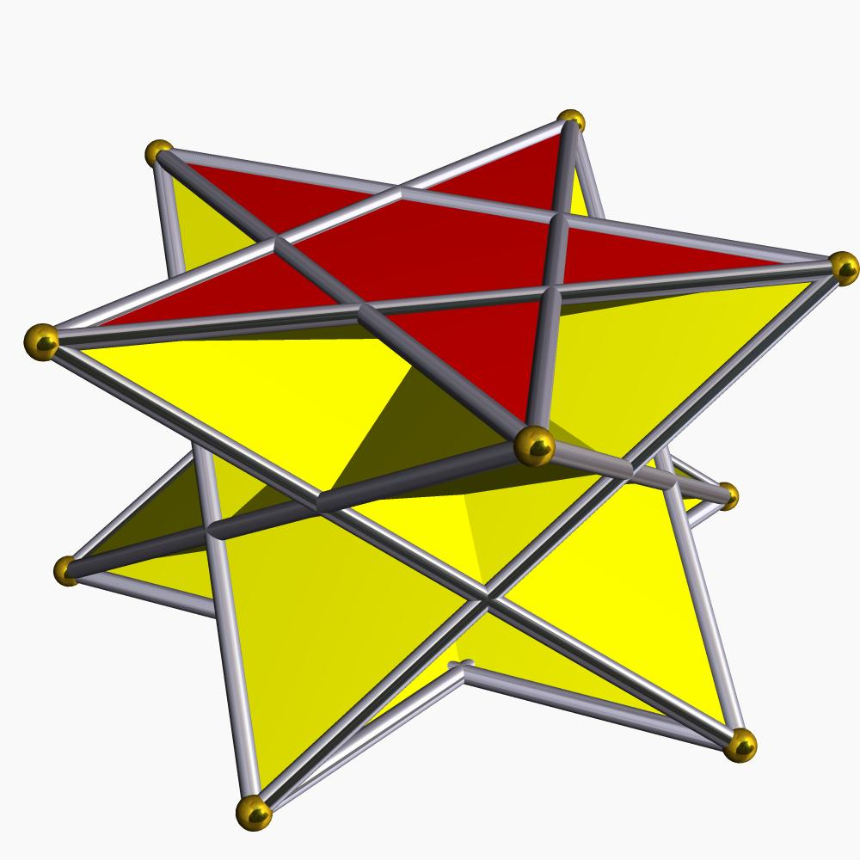

Constructing a Star-Cuploid in Solid Geometry

Geometric Instruments Used
# Source: AI Source: Provided by: [Data Path: Persons Table -> ID Column: 1, Name_En Column: Motasem Essam] -> From: [ChatGPT] on [7/25/2026]
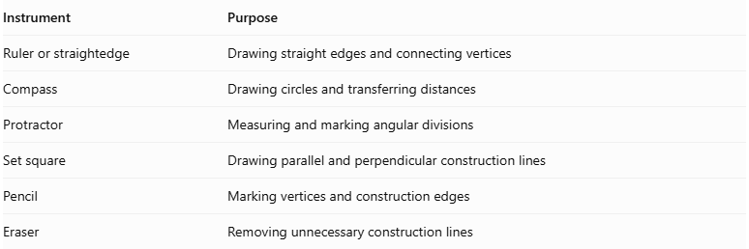
Instrument | Purpose
Ruler or straightedge | Drawing straight edges and connecting vertices
Compass | Drawing circles and transferring distances
Protractor | Measuring and marking angular divisions
Set square | Drawing parallel and perpendicular construction lines
Pencil | Marking vertices and construction edges
Eraser | Removing unnecessary construction lines
Construction method: Instrument-based geometric construction using geometric instruments, angular measurements, and geometric relationships. It does not use coordinate-based construction.

Instrument-Based Construction Procedures

Selecting the Star-Cuploid Type
# Source: AI Source: Provided by: [Data Path: Persons Table -> ID Column: 1, Name_En Column: Motasem Essam] -> From: [ChatGPT] on [7/25/2026]
- Select the intended Star-Cuploid configuration.
- Determine the upper and lower base polygons.
- Identify the star-polygon notation for each star-shaped base.
- Determine the number of vertices on each base.
- Establish the required lateral-face arrangement.

Constructing the Upper Star Polygon
# Source: AI Source: Provided by: [Data Path: Persons Table -> ID Column: 1, Name_En Column: Motasem Essam] -> From: [ChatGPT] on [7/25/2026]
- Draw a circle using a compass.
- Mark equally spaced points around its circumference.
- Number the vertices consecutively.
- Connect the vertices according to the selected star-polygon connection step.
- Complete the upper star polygon.
For a star polygon $\{n/k\}$, connect each vertex to the vertex $k$ positions ahead, wrapping around the numbering when necessary.

Constructing the Lower Base
# Source: AI Source: Provided by: [Data Path: Persons Table -> ID Column: 1, Name_En Column: Motasem Essam] -> From: [ChatGPT] on [7/25/2026]
- Draw a second circle for the lower base.
- Mark the required number of equally spaced vertices.
- Construct the ordinary polygon or star polygon selected for the lower base.
- Complete the base outline and its internal star connections, if applicable.

Positioning the Two Bases
# Source: AI Source: Provided by: [Data Path: Persons Table -> ID Column: 1, Name_En Column: Motasem Essam] -> From: [ChatGPT] on [7/25/2026]
- Represent the two bases as parallel planes.
- Position the upper base above the lower base.
- Align their orientations according to the intended cuploid configuration.
- Maintain the intended rotational symmetry.
- Ensure that the vertex positions are compatible with the lateral-face arrangement.

Constructing the Lateral Faces
# Source: AI Source: Provided by: [Data Path: Persons Table -> ID Column: 1, Name_En Column: Motasem Essam] -> From: [ChatGPT] on [7/25/2026]
- Identify the corresponding vertices and edges of the two bases.
- Connect the bases according to the selected cuploid topology.
- Construct the required triangular or other polygonal lateral faces.
- Check that adjacent faces share matching edges.
- Complete the lateral structure without introducing unintended connections.
- Verify that the intended solid is properly closed.

Completing the Three-Dimensional Representation
# Source: AI Source: Provided by: [Data Path: Persons Table -> ID Column: 1, Name_En Column: Motasem Essam] -> From: [ChatGPT] on [7/25/2026]
- Darken the visible edges.
- Use dashed lines for hidden edges where appropriate.
- Preserve the star-shaped appearance of the bases.
- Check the symmetry and face arrangement.
- Verify that the completed representation matches the selected Star-Cuploid configuration.
Construction accuracy note: The exact construction depends on the selected regular polygons. Some regular polygons can be constructed exactly with a compass and unmarked straightedge, while others require measured-angle instruments or approximate construction. A protractor can be used to mark angular divisions. These procedures are instrument-based, not coordinate-based.

Key Points
# Source: AI Source: Provided by: [Data Path: Persons Table -> ID Column: 1, Name_En Column: Motasem Essam] -> From: [ChatGPT] on [7/25/2026]
- A Star-Cuploid is related to the star-cupola family.
- It is a non-convex or crossed polyhedral construction.
- It has a star-shaped polygonal base.
- Its lateral structure contains triangular and square faces.
- Its lower polygonal base is degenerate and removed.
- It is non-orientable.
- Its geometry is described using the notation $\{n/d\}$.
- Its structure depends on the selected star polygon.
- Examples include pentagrammic and heptagrammic cuploids.

Conclusion
# Source: AI Source: Provided by: [Data Path: Persons Table -> ID Column: 1, Name_En Column: Motasem Essam] -> From: [ChatGPT] on [7/25/2026]
The Star-Cuploid is a specialized polyhedral structure related to star cupolas. It is characterized by a star-shaped polygonal base, triangular and square lateral faces, and a crossed arrangement created by removing the degenerate lower base.
Its non-orientable structure and star-polygon geometry make it an interesting subject in the study of non-convex polyhedra and advanced solid geometry.

